To do list:

Home Page:

Change picture to

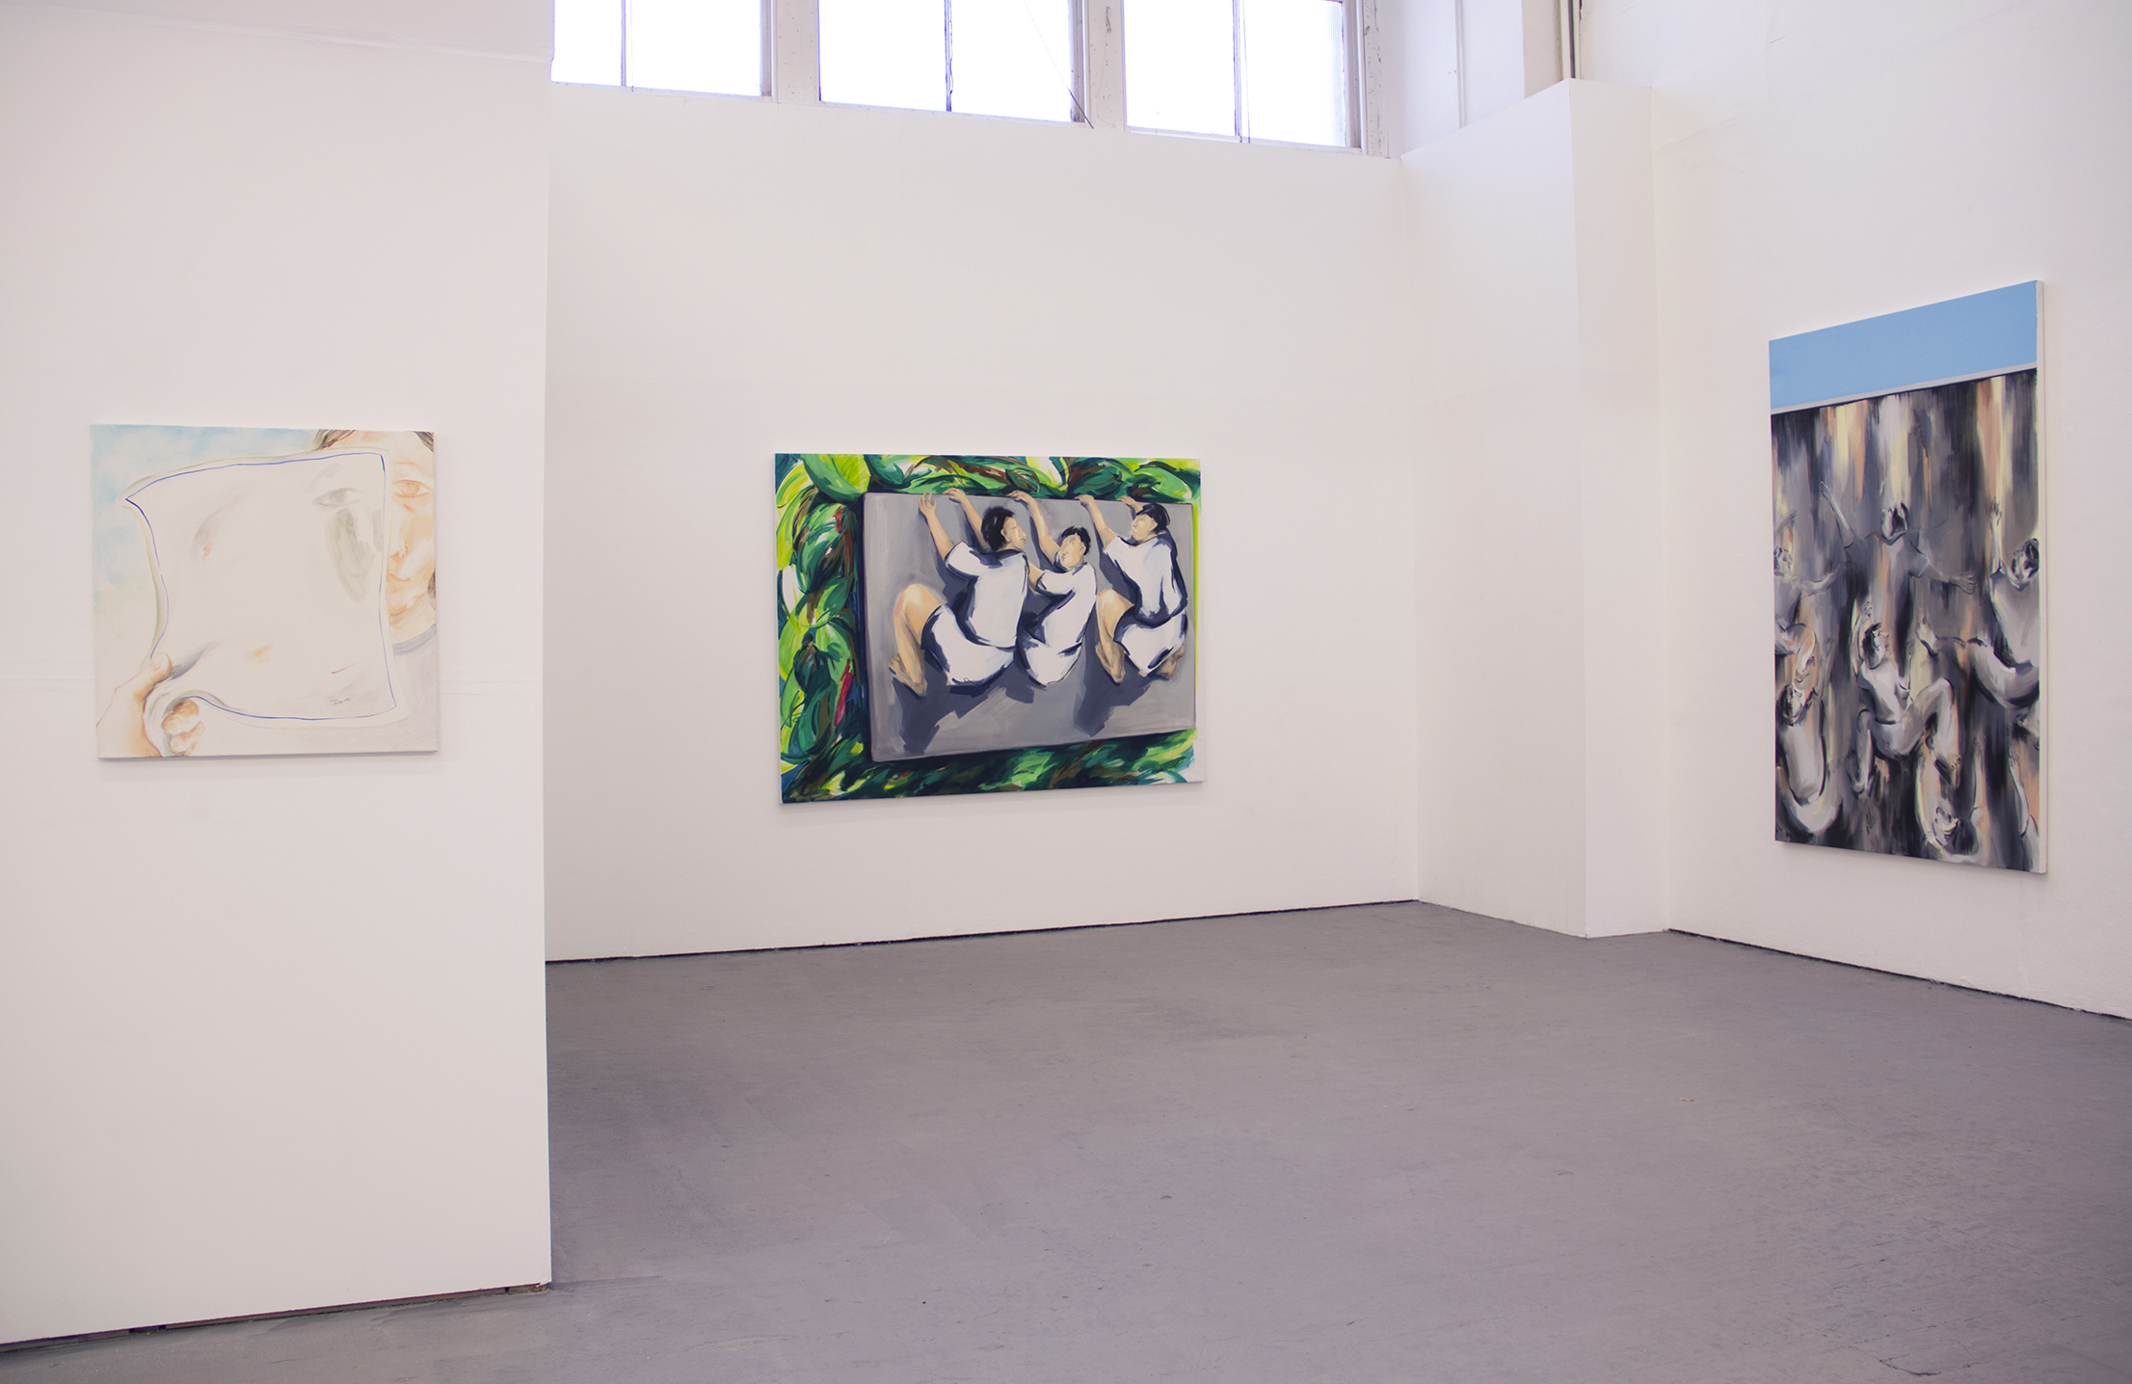

Change © Yvonne Feng 2017 to © Yvonne Feng 2018

**Work III**

Change title Work III to An Amnesiac’s Stories

Add picture and description:

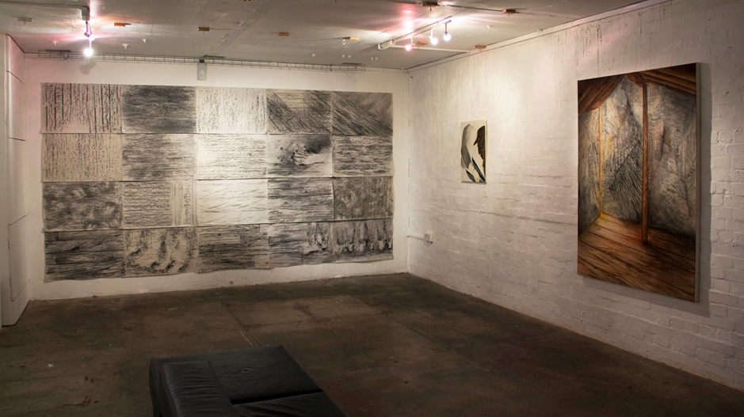

*An Amnesiac’s Stories*

2015

Exhibition installation view

Hundred Years Gallery, London

**Work II**

Change title Work II to Telescreens

**Work I**

Change title Work I to Greener On The Other Side?

Delete the following paintings:

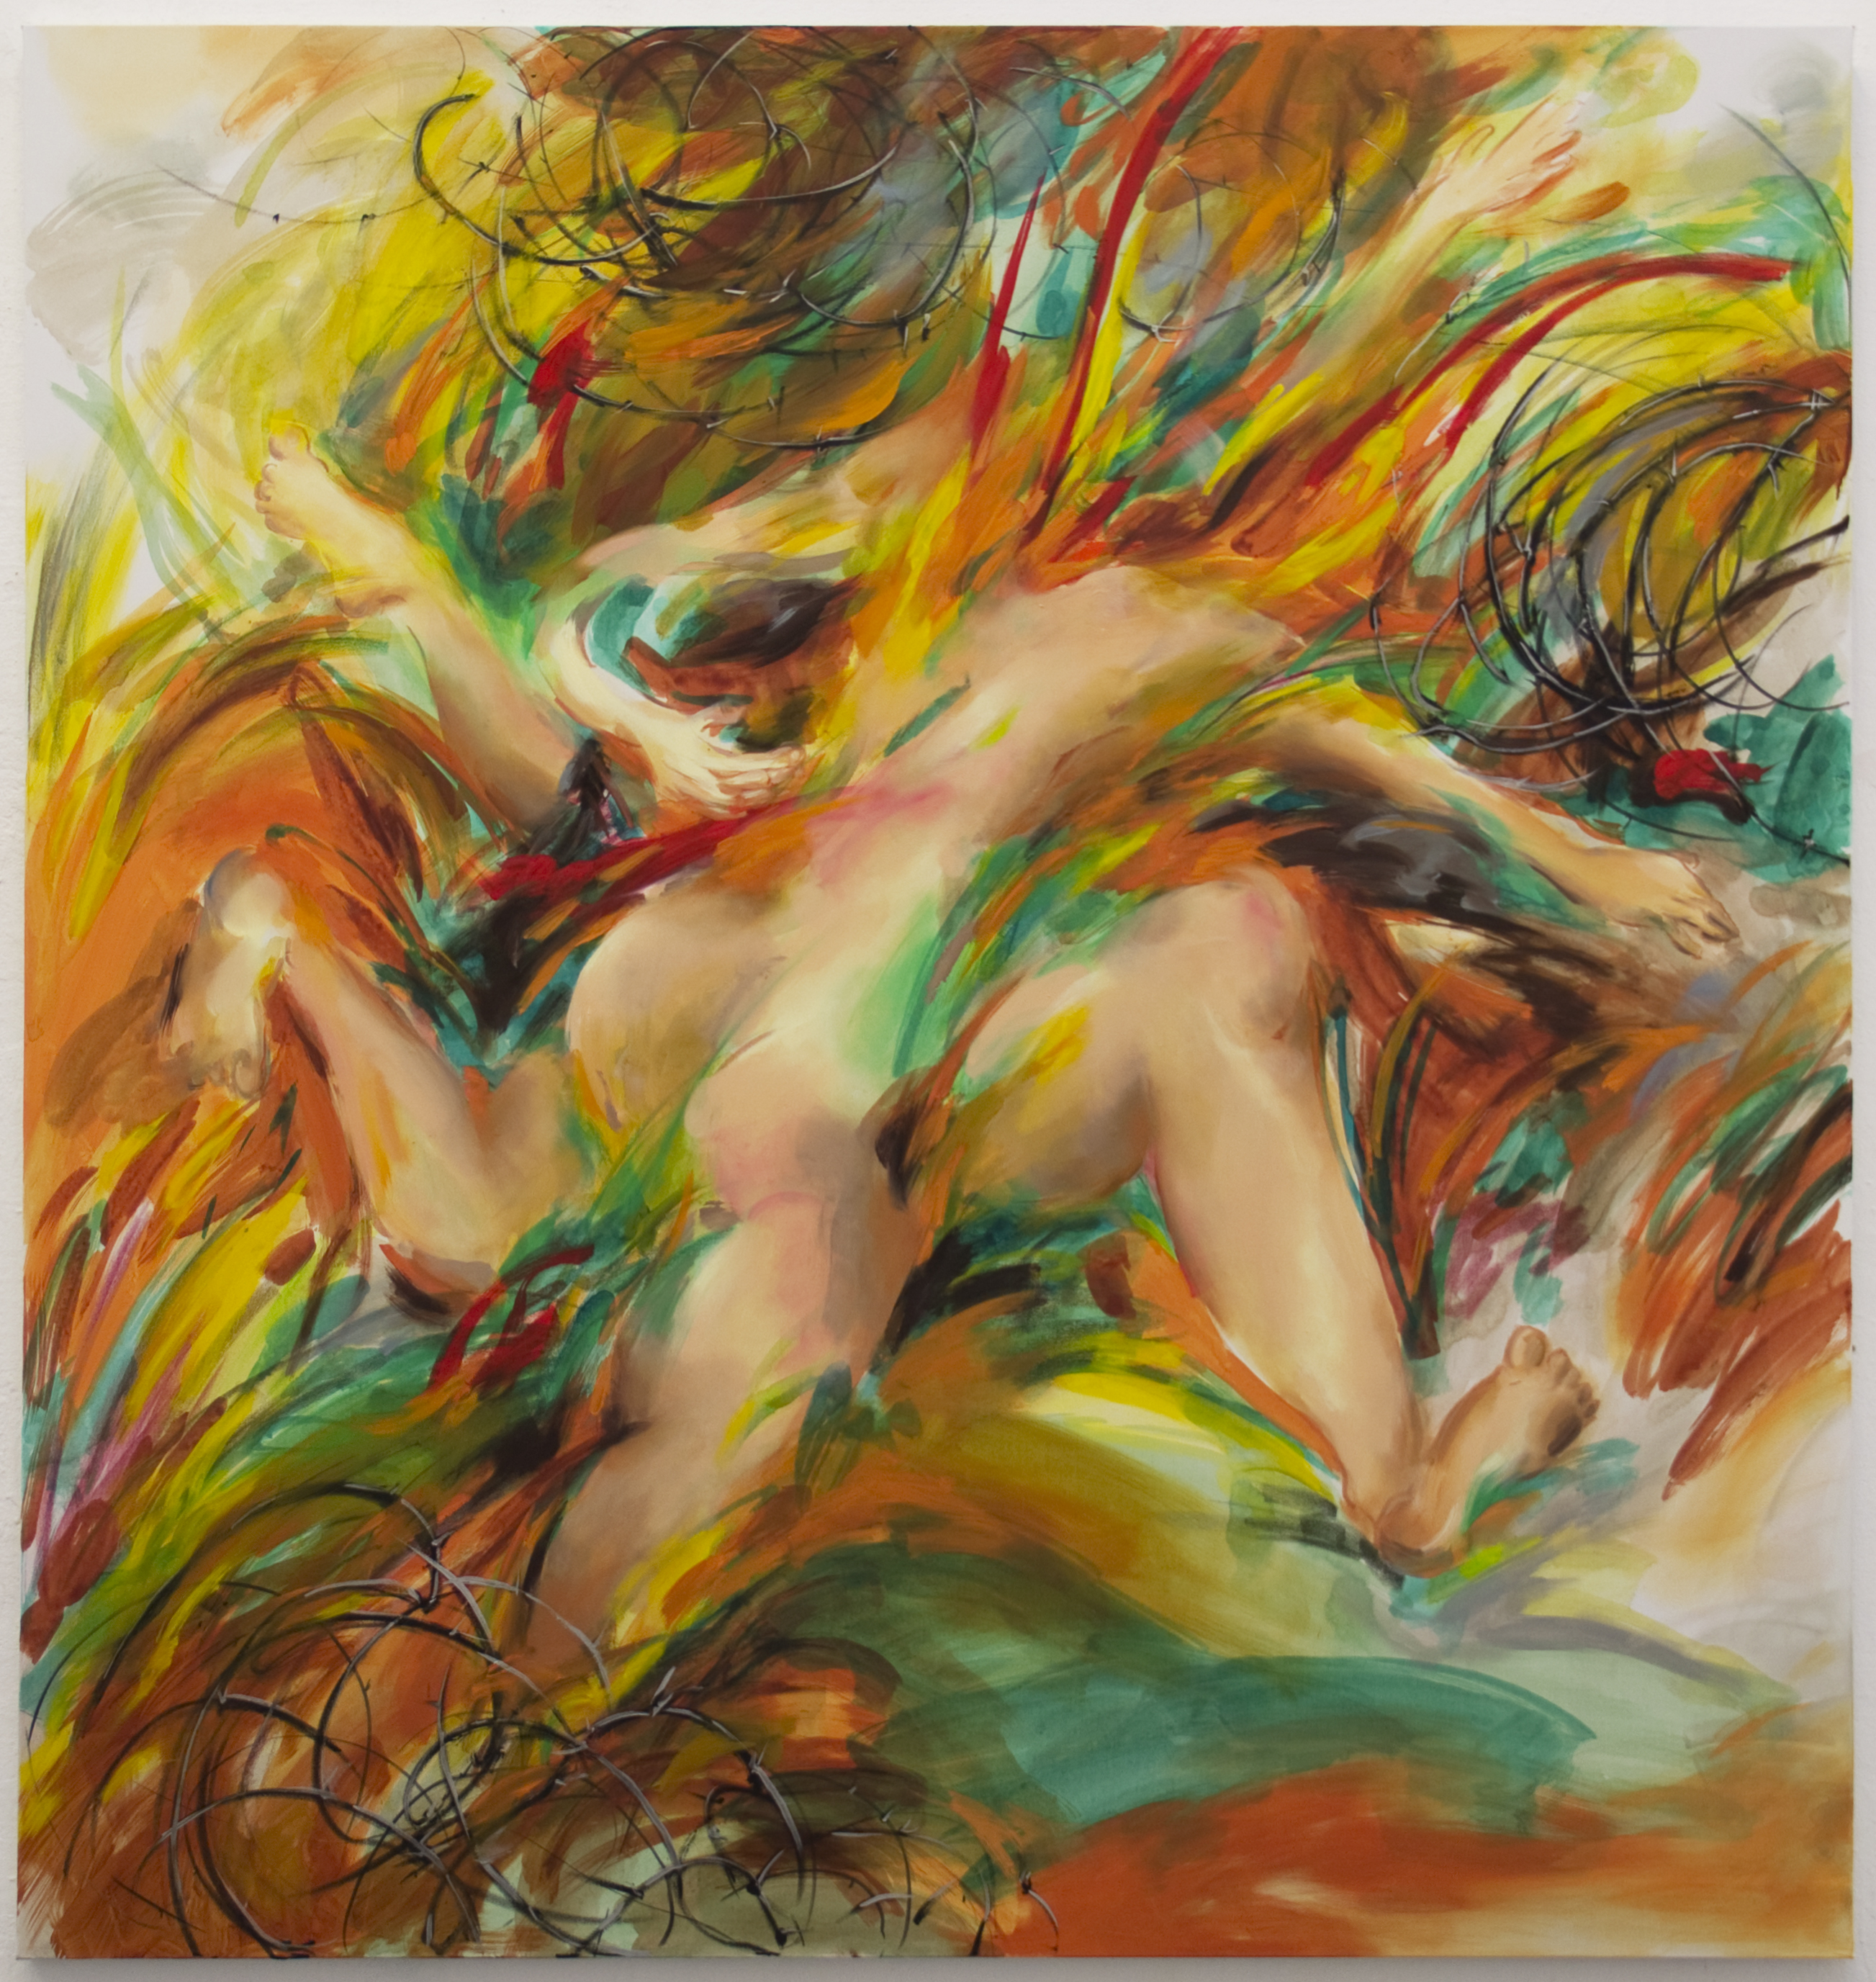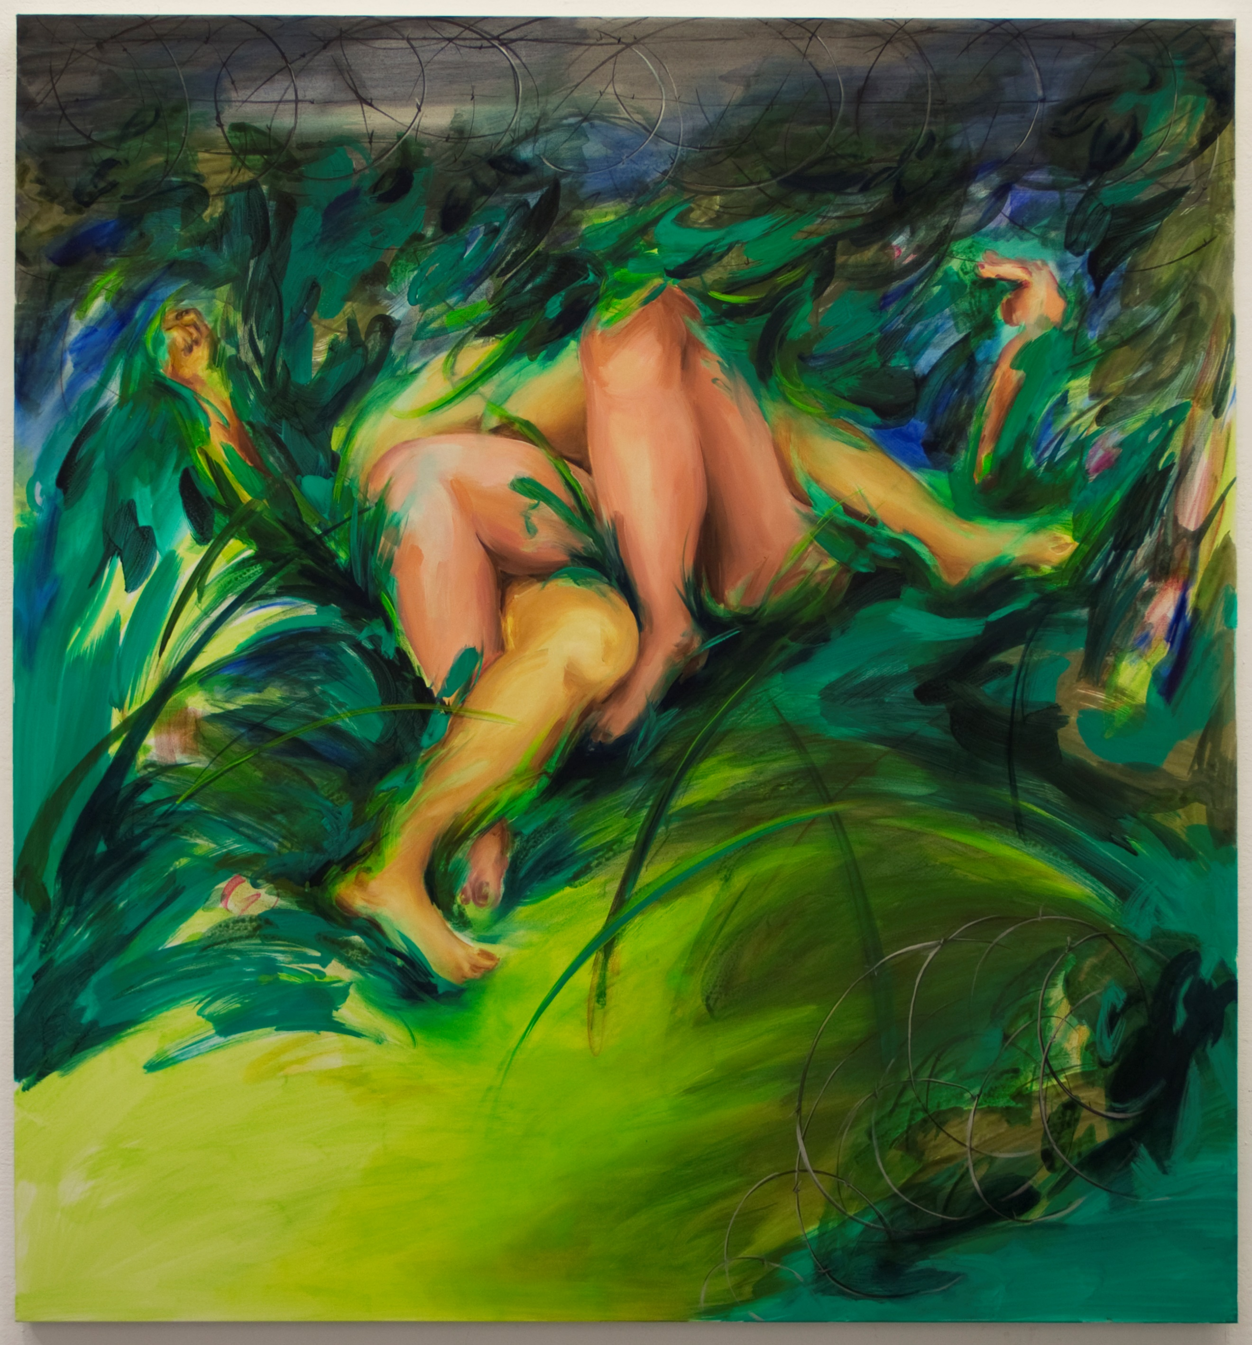

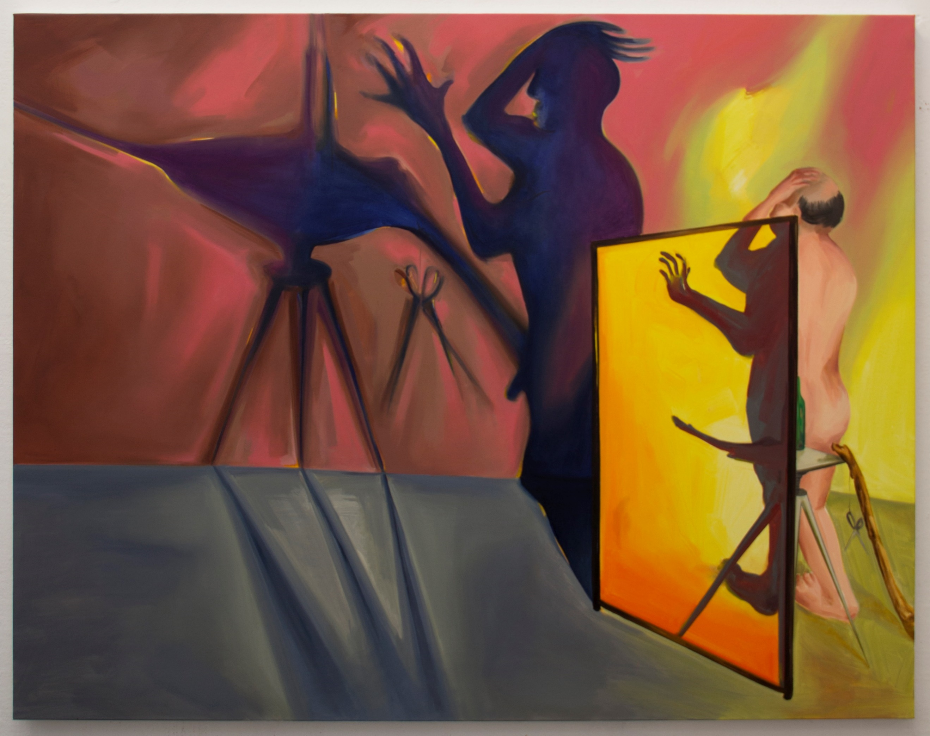

Add

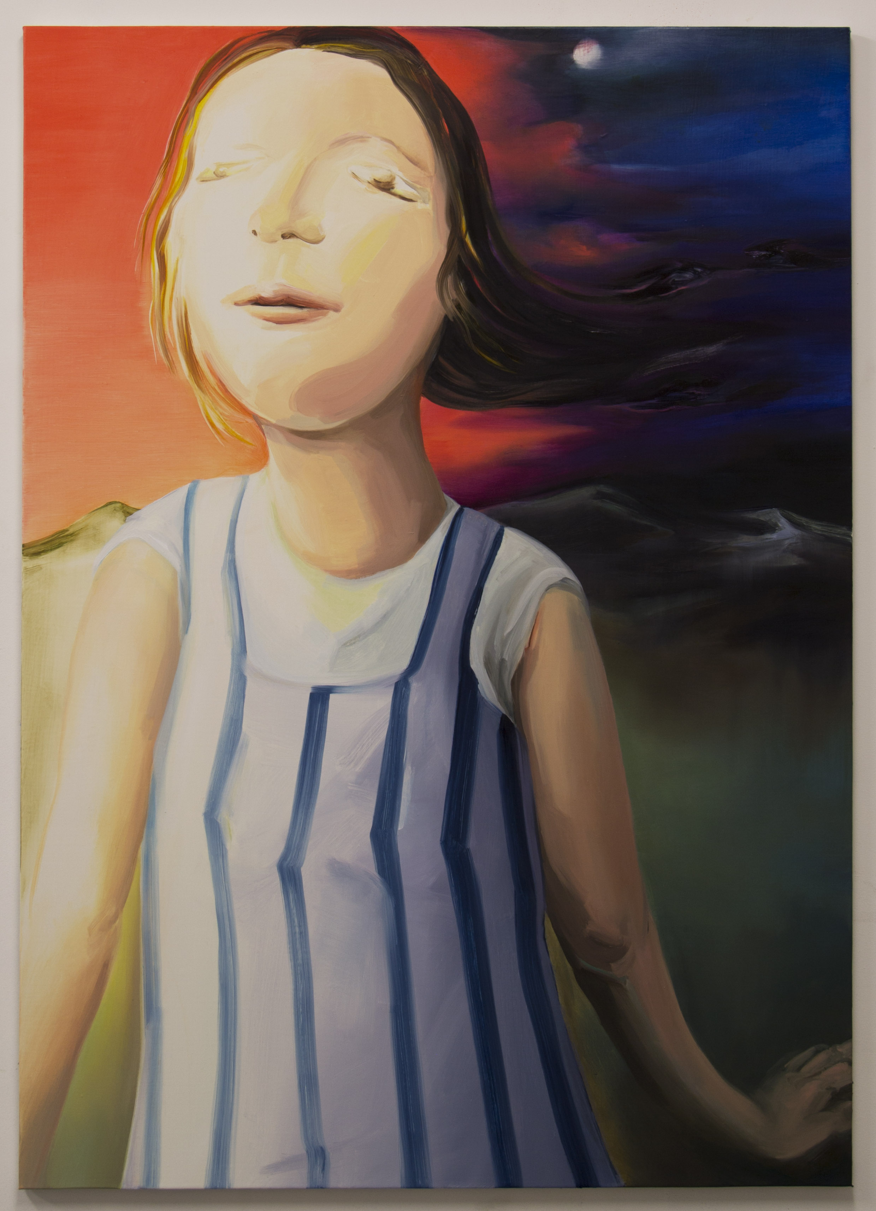

*I have come this far*

2017

Oil on canvas

106.5 x 76cm



*Slade Graduate Degree Show*

2017

Exhibition installation view

Slade School of Fine Art, London

**Add new page under Work – Body as Metaphor**

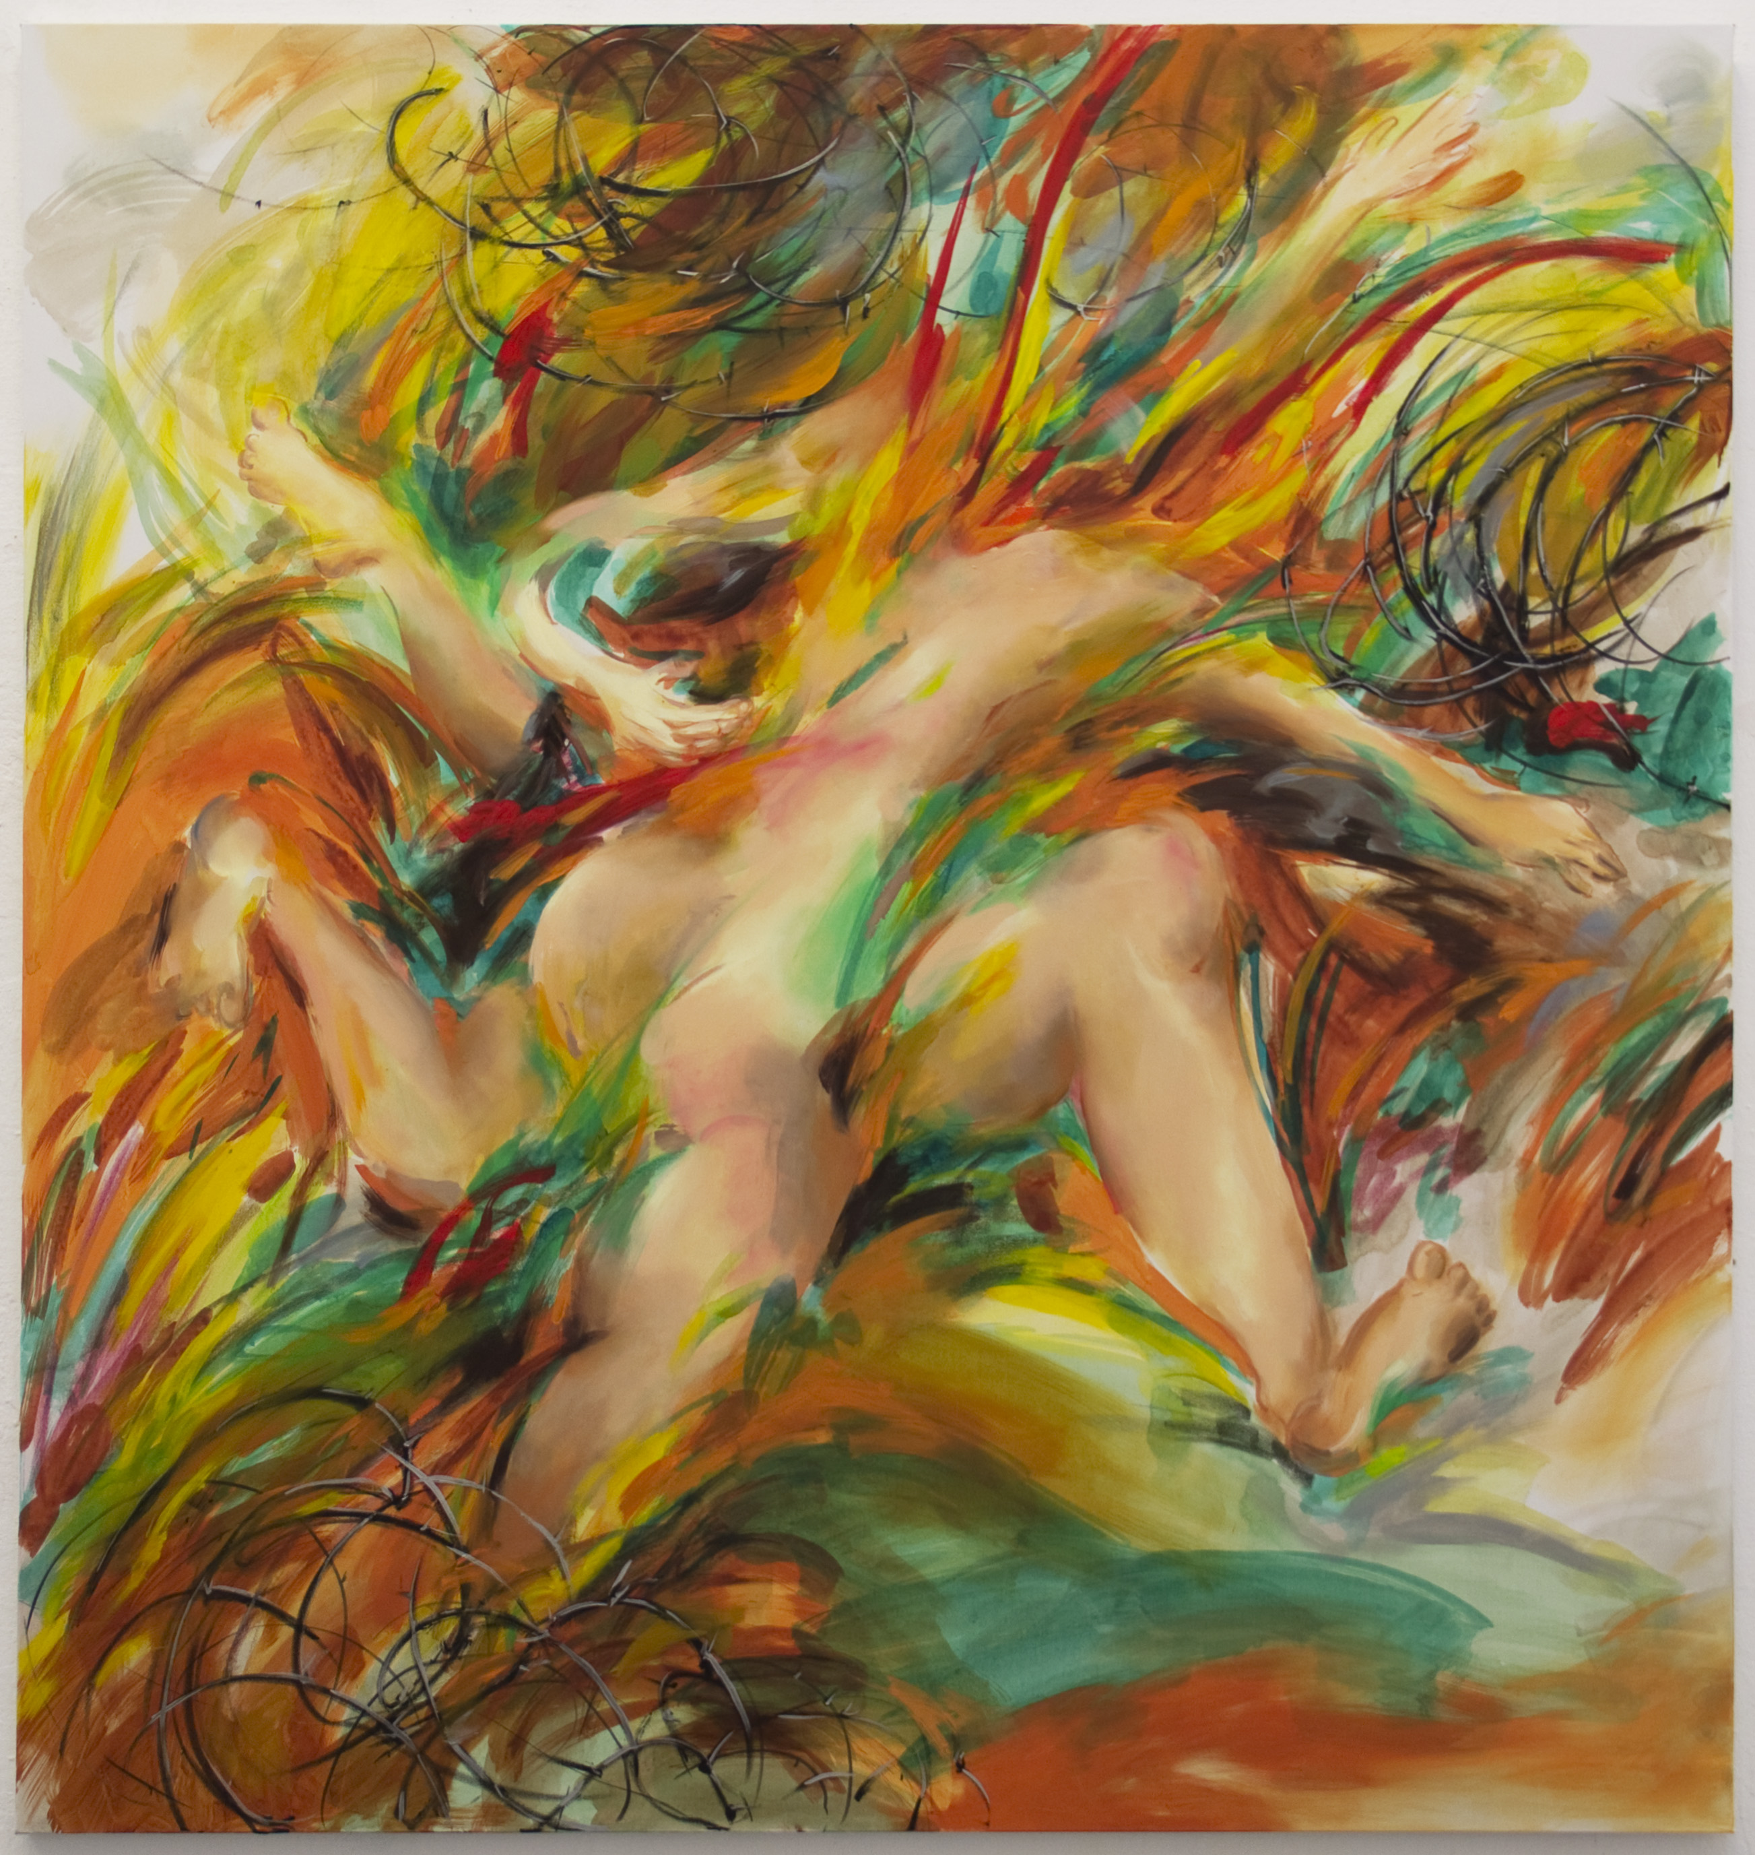

*A rebellious act*

2017

Pastel, acrylic and oil on canvas

170 x 160cm

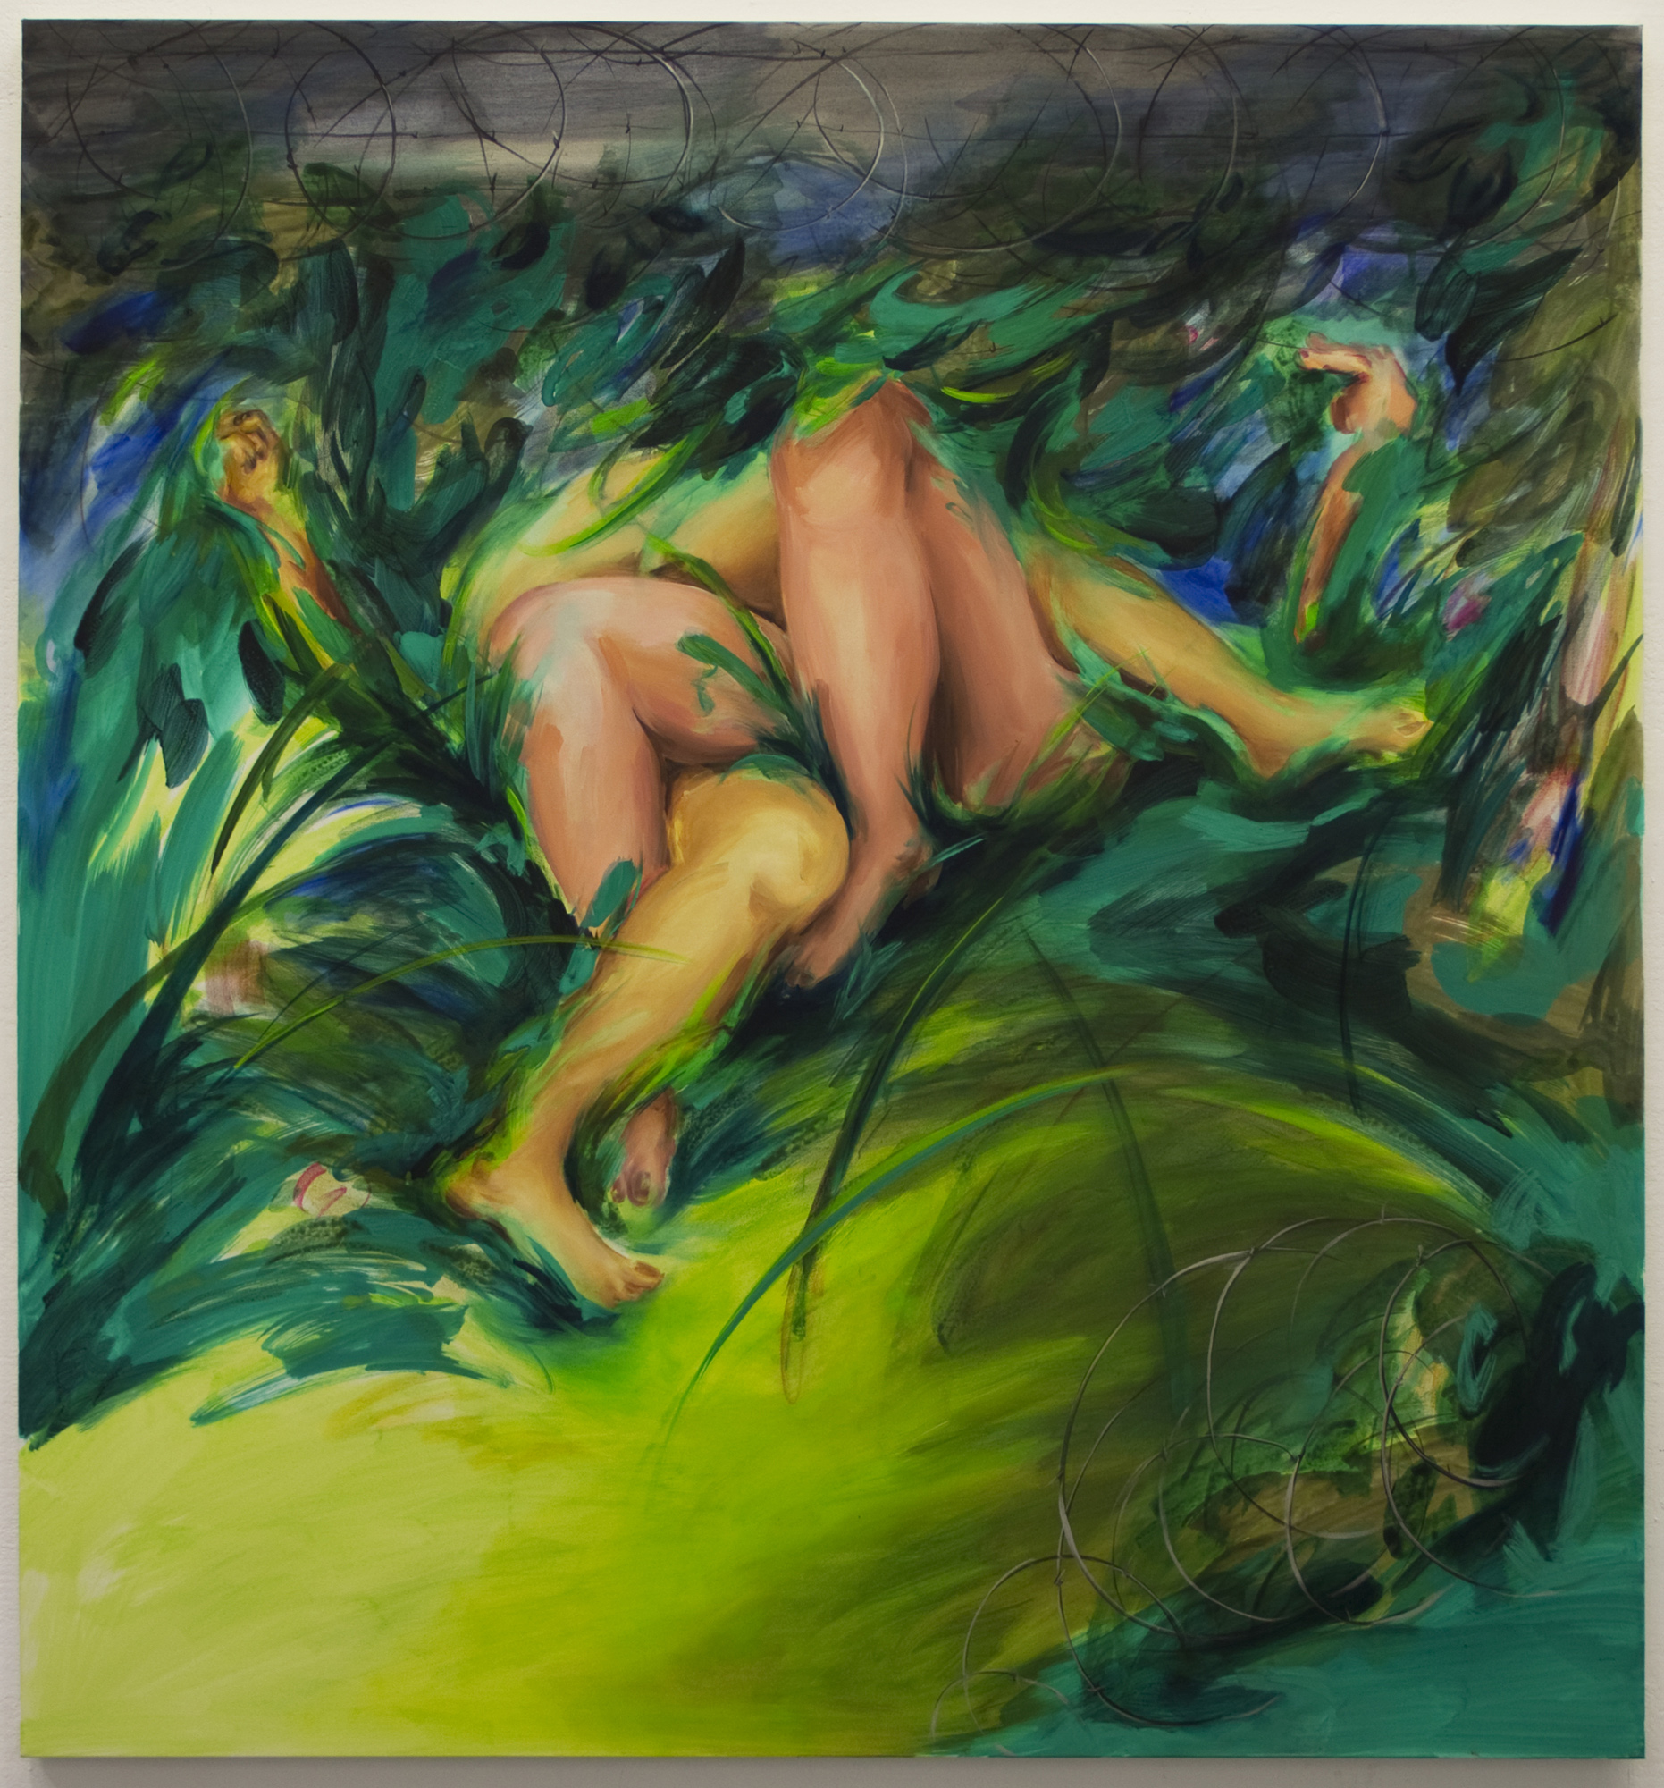

*Climax a victory*

2016

Pastel, acrylic and oil on canvas

170 x 160cm

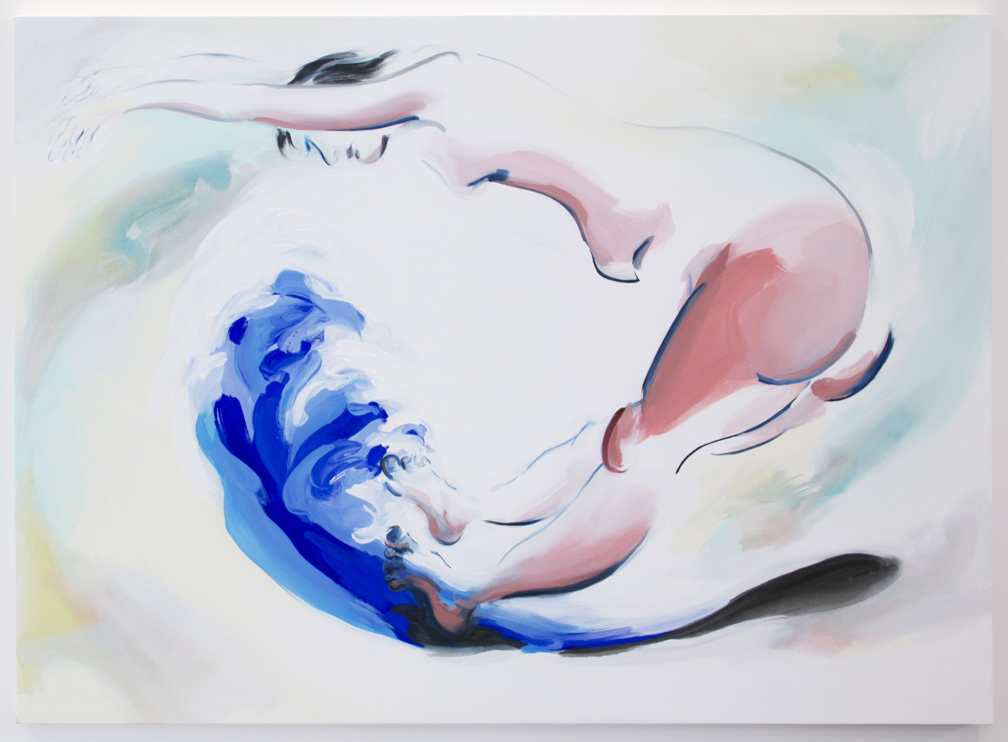

*Vicissitudes of life (up)*

2017

Acrylic, pigment and oil on canvas

130 x 180cm

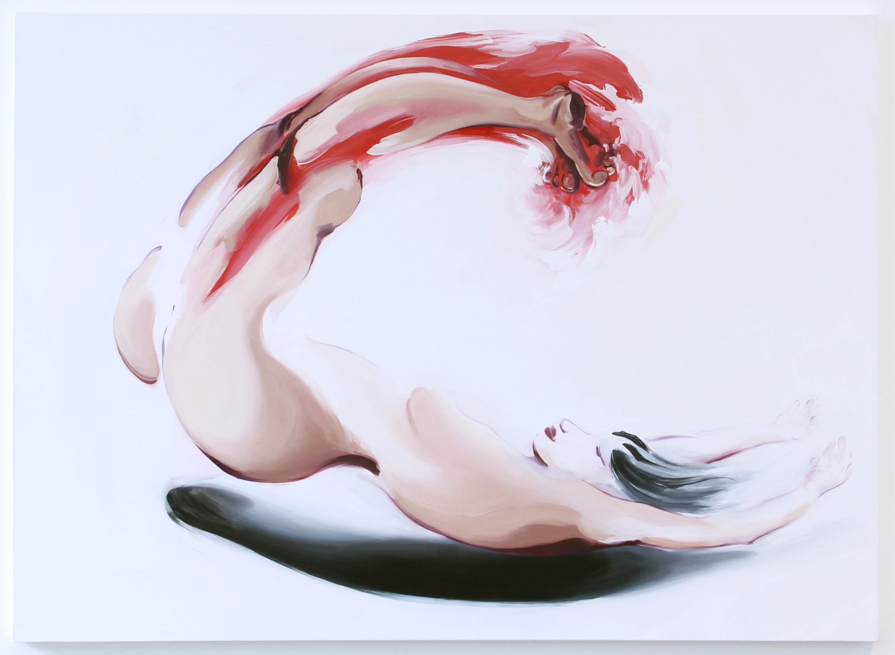

*Vicissitudes of life (down)*

2017

Acrylic, pigment and oil on canvas

130 x 180cm

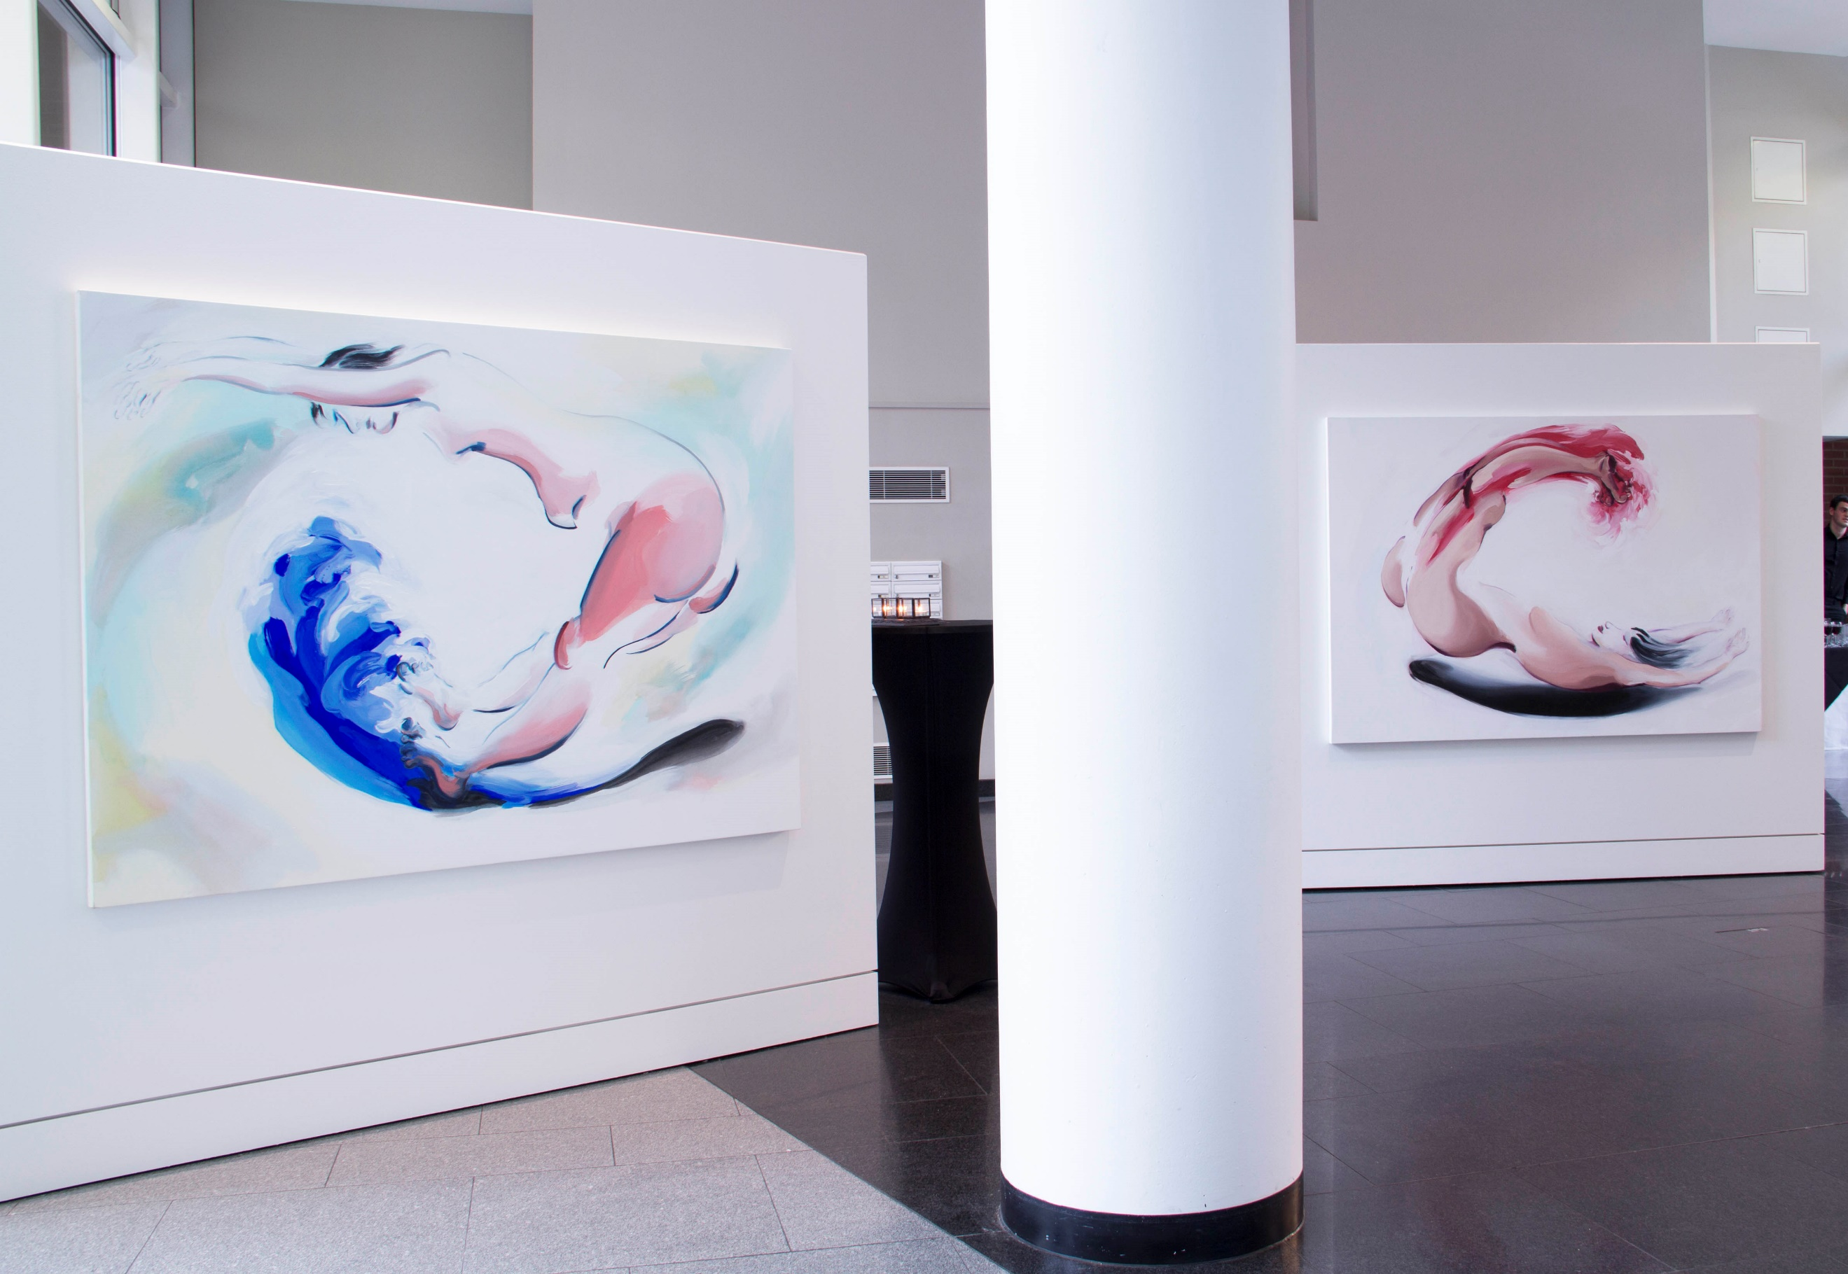

*Mise-en-scène*

2017

Exhibition installation view

Chelsea Waterside ArtSpace, London

**New titles and page order for Work**

Greener On The Other Side?

Body as Metaphor

Telescreens

An Amnesiac’s Stories

**CV**

Add

2018

She Performs, London Gallery West Project Space, London

2017

*Beyond the Borders: Joseonjok’s Ambiguous Identity,* Crypt Gallery, London

**News:**

Add

She Performs (link: <https://www.sheperforms.com/> )

14th-17th June 2018

London Gallery West Project Space, London HA1 3TP

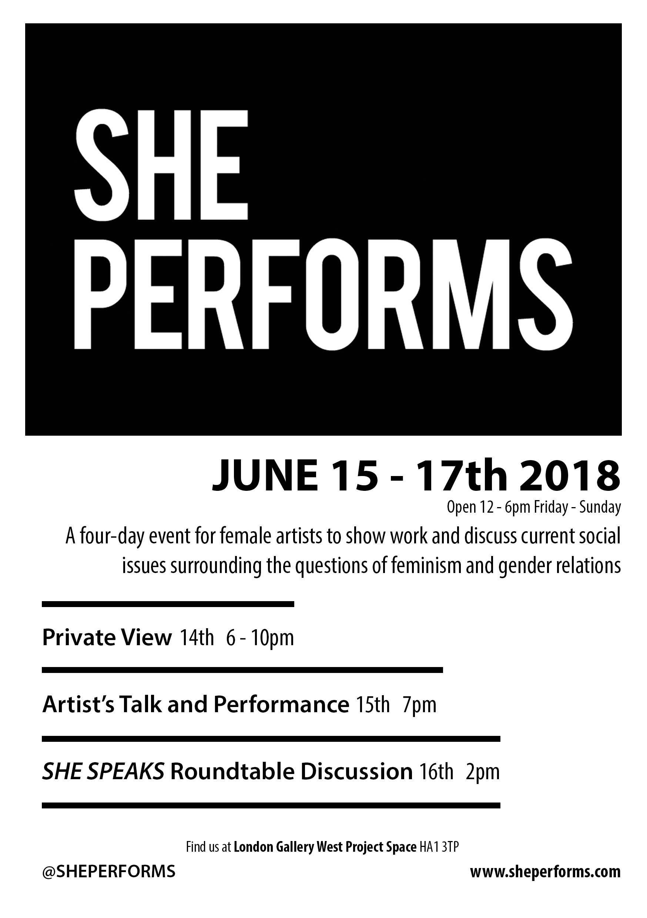

Mise-en-scène

20th September – 15th November 2017

Chelsea Waterside ArtSpace, Hepworth Court, Grosvenor Waterside, Gatliff Road, London SW1W 8QP

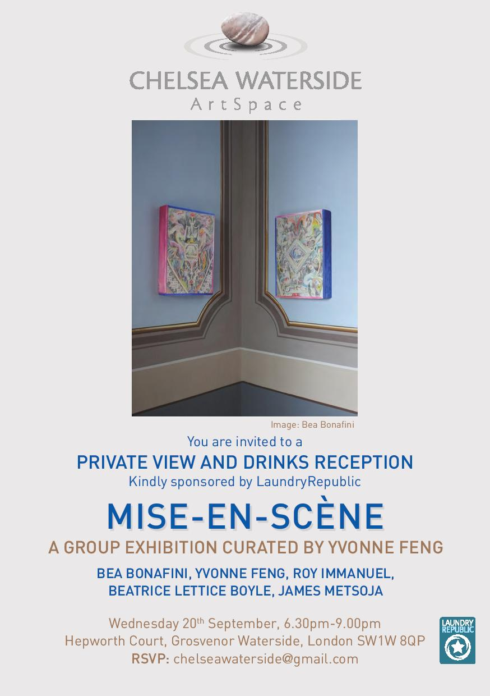

Hauntopia / What If (link: <http://www.artresearch.eu/2017/04/19/earn-conference-venice-programme-sept-8-9-2017/> )

8th -9th September 2017

Research Pavilion, Sala del Camino, Campo S. Cosmo, Giudecca 621, 30133 Venice, Italy